***Grace Bridal Store Detailed Project***

***Home page http://localhost:8080/GraceBridalStore/Home.html***

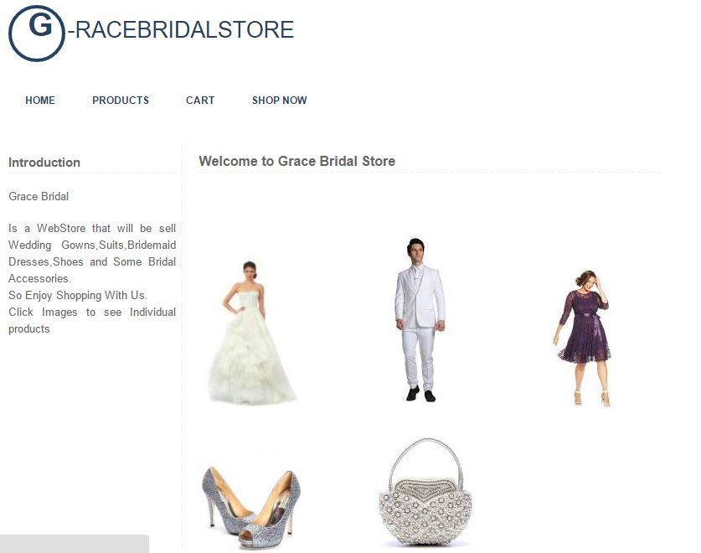

**Grace Bridal Home page** has an image that links to each individual product and also it has four main links found in every page.

*Gown*  *Suits Bride maid dresses*

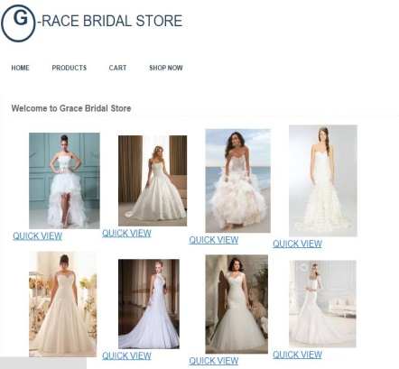 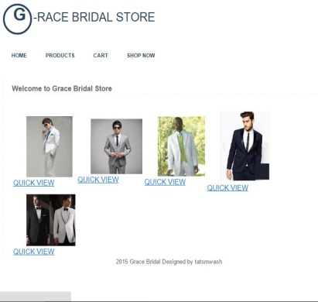 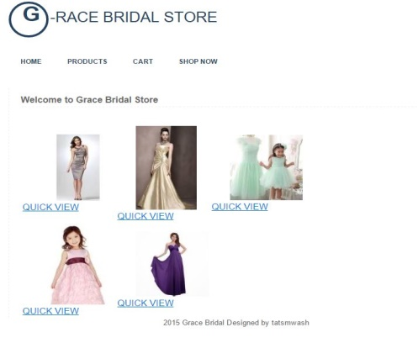

*Shoes*  *Accessories*

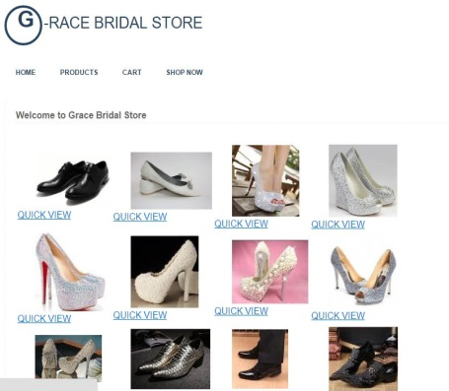 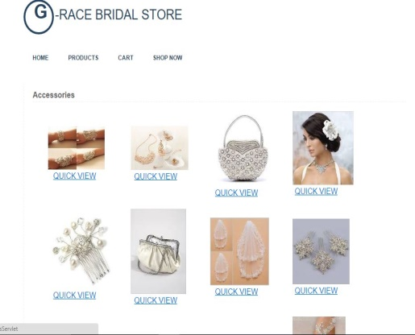

Individual products with a **Quick View** link that takes you to view images details.

***Details page***

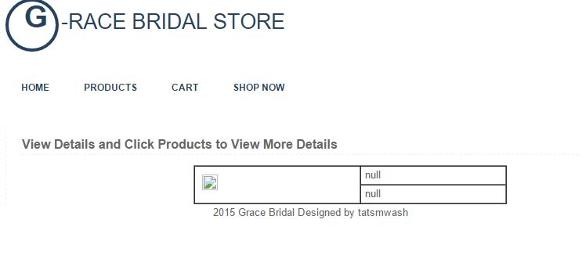

The details page has problem showing the details but for more details you can click **products** link.

***Products Page http://localhost:8080/GraceBridalStore/ProductServlet***

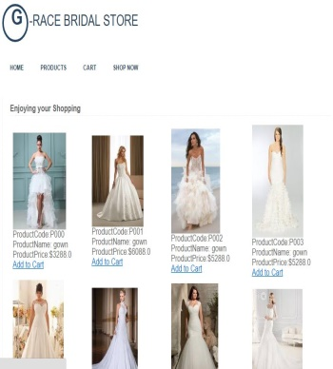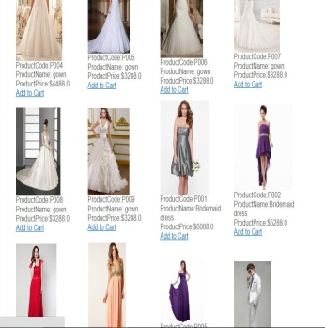 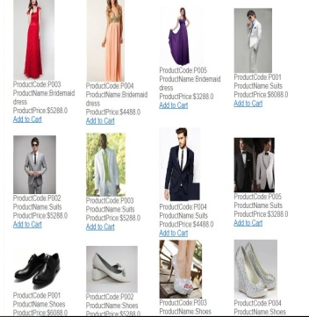 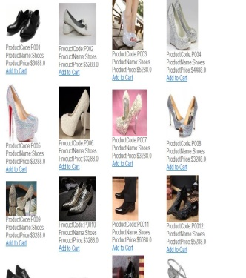

 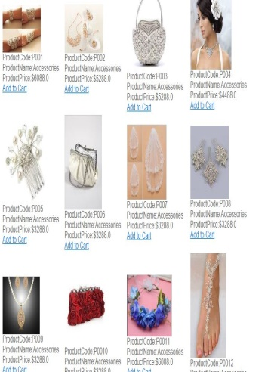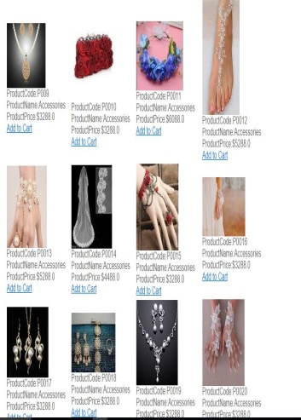 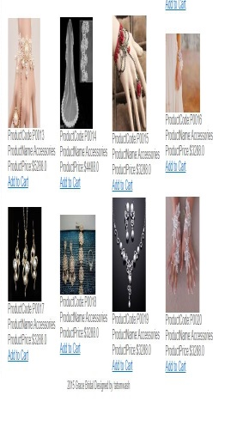

When the **add to cart** is clicked it takes the product to the cart.

***Cart Page***

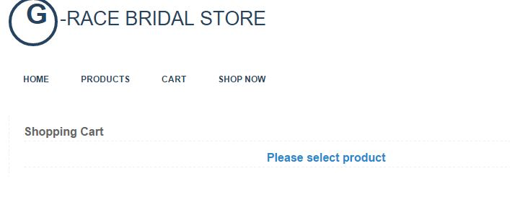 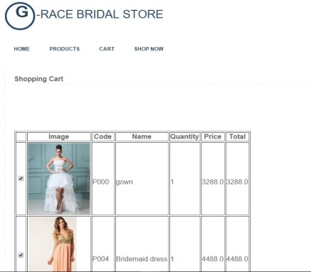 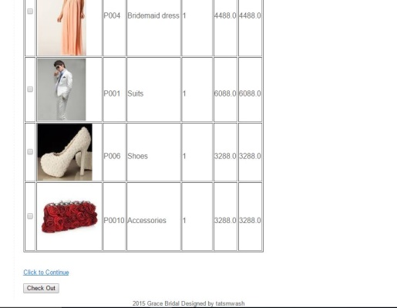

In Cart there are two options either to **continue** with adding to cart or **check out**. When Check out is clicked customer information is required and it is served to database

***Customer Info***

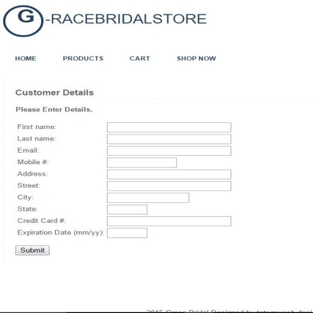 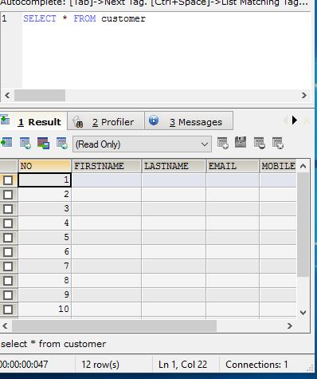

After clicking submits the **customer details** will be sending to **database** and a **success** message will be send.

***Thank You Page***

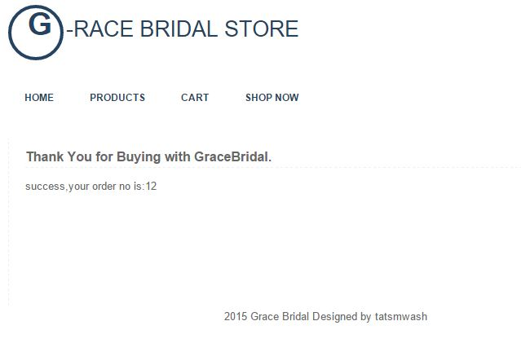  
Hope You Enjoy Shopping with Grace Bridal this festive season. Happy Holidays.